|  |  |
| --- | --- |
| PLANNING PROPOSAL  Amendment to the Narrabri Local Environmental Plan 2012 | image001 (2) |

**Planning Proposal 5/2019**

**Proposed Amendment to Narrabri Local Environmental Plan 2012**

**Rezone Existing B1 Neighbourhood Centre to B4 Mixed Use in West Narrabri**

**Version 01**

# PART 1: OBJECTIVES OR INTENDED OUTCOMES

## SECTION A – BACKGROUND

A core objective of Council’s Operational Plan is the ‘review and development of statutory and non-statutory plans to ensure for orderly and sustainable development’. As part of Council’s commitment to this objective Council Staff have been completing a review of the Narrabri Local Environmental Plan (LEP) 2012 Land Use Table. The Narrabri LEP 2012 is the statutory environmental planning instrument applicable to development in the Narrabri Local Government Area (LGA).

The Narrabri LEP 2012 Land Use Table review has focused on the RU1 Primary Production, IN1 General Industrial, IN2 Light Industrial and B1 Neighbourhood Centre land use zonings.

This planning proposal relates only to the B1 Neighbourhood Centre zone located in West Narrabri, and the changes sought to this land as an outcome of the Narrabri LEP 2012 review.

The scope of the review as it related to the B1 Neighbourhood Centre zone was:

* Identification of land uses permitted without consent, permitted with consent and prohibited within the land use zone,
* Review of the prohibited land uses in the B1 Neighbourhood Centre zone in context with the following:
* Identify the range of land uses that would be reasonable to be permitted with consent in the B1 Neighbourhood Centre zone, considering the vision and goals of the *New England North West Regional Plan 2036.* In particular, the *Regional Plan* sets the following regionally focused goals:
  + A strong and dynamic regional economy;
  + A healthy environment with pristine waterways;
  + Strong infrastructure and transport networks for a connected future;
  + Attractive and thriving communities.
* Consider alternative uses that support the objectives of the existing B1 Neighbourhood Centre zone to broaden the scope to allow consideration of uses that are likely to have positive outcomes in terms of supporting the vision and goals of the *Regional Plan*.
* Review the range of land uses permissible in the B1 Neighbourhood Centre zone for LGA’s in the North West Region that have similar characteristics to Narrabri LGA.
* Identify the range of land uses that would be reasonable to be permitted in the B1 Neighbourhood Centre zone given the findings of the above review, with a particular emphasis on ensuring that the B1 Neighbourhood Centre zone has the capacity and flexibility to adapt to changing land use and opportunities arising from the directions and focus on building strong economic centres identified in the *Regional Plan.*
* Identify any changes to the land use zone objectives considered to be logical or necessary to improve the versatility of the B1 Neighbourhood Centre zone and support the changes to the Land Use Table recommended by the review.

This planning proposal has been informed by the Narrabri LEP 2012 Land Use Table Review, as completed to date.

Following the Narrabri LEP 2012 Land Use Table Review, consideration of the vision and goals set by the *New England North West Regional Plan 2036* and review of the *Narrabri Shire Growth Management Strategy 2009,* Council has determined that the most appropriate zone for the West Narrabri land is B4 Mixed Use as recommended in the *Growth Management Strategy* rather than B1 Neighbourhood Centre.

This document sets out the justification for and explains the intended effect of the recommended amendment.

## SECTION B – OBJECTIVES

The objectives and intended outcomes of this planning proposal are:

1. To rezone the B1 Neighbourhood Centre land at West Narrabri to B4 Mixed Use under the Narrabri LEP 2012 to account for the following:
2. To ensure the range of development permitted within the Narrabri West precinct accounts for changing land use pressures and opportunities associated with the vision, goals and directions set out in the *New England North West Regional Plan 2036.*
3. To bring the Narrabri LEP 2012 into line with the *Narrabri Shire Growth Management Strategy* in relation to the West Narrabri land.
4. There will be no changes made to the Minimum Lot Size (MLS), Floor Space Ratio (FSR) or the Height of Building (HoB) provisions or maps within the Narrabri LEP 2012.

# PART 2: EXPLANATION OF PROVISIONS

To achieve the planning proposal’s objectives, it is proposed to rezone the land located at West Narrabri that is currently zoned B1 Neighbourhood Centre to B4 Mixed Use under the Narrabri LEP 2012.

The proposed change will require a modification to the LEP 2012 map as shown below in its current form;

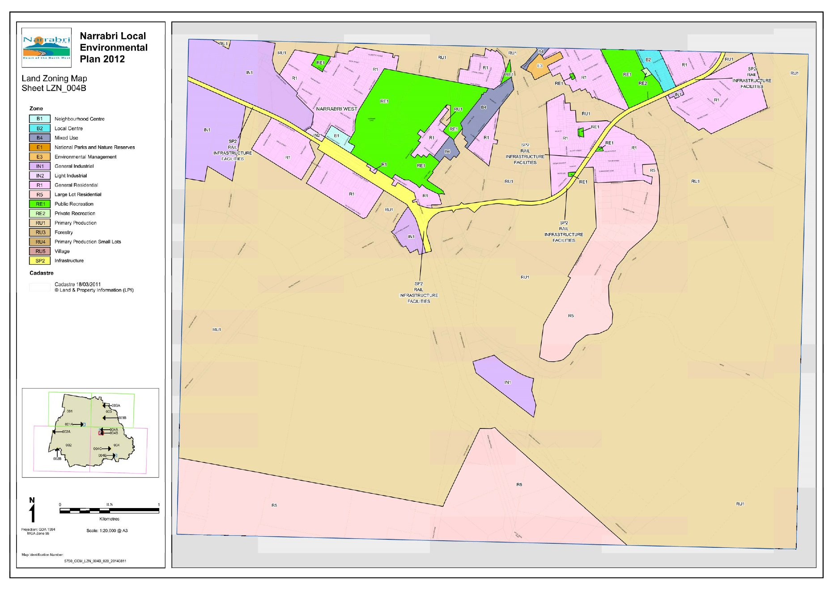

*Figure 1 – Current B1 Land Use Zoning.*

To the proposed zoning as shown in the following map extract;

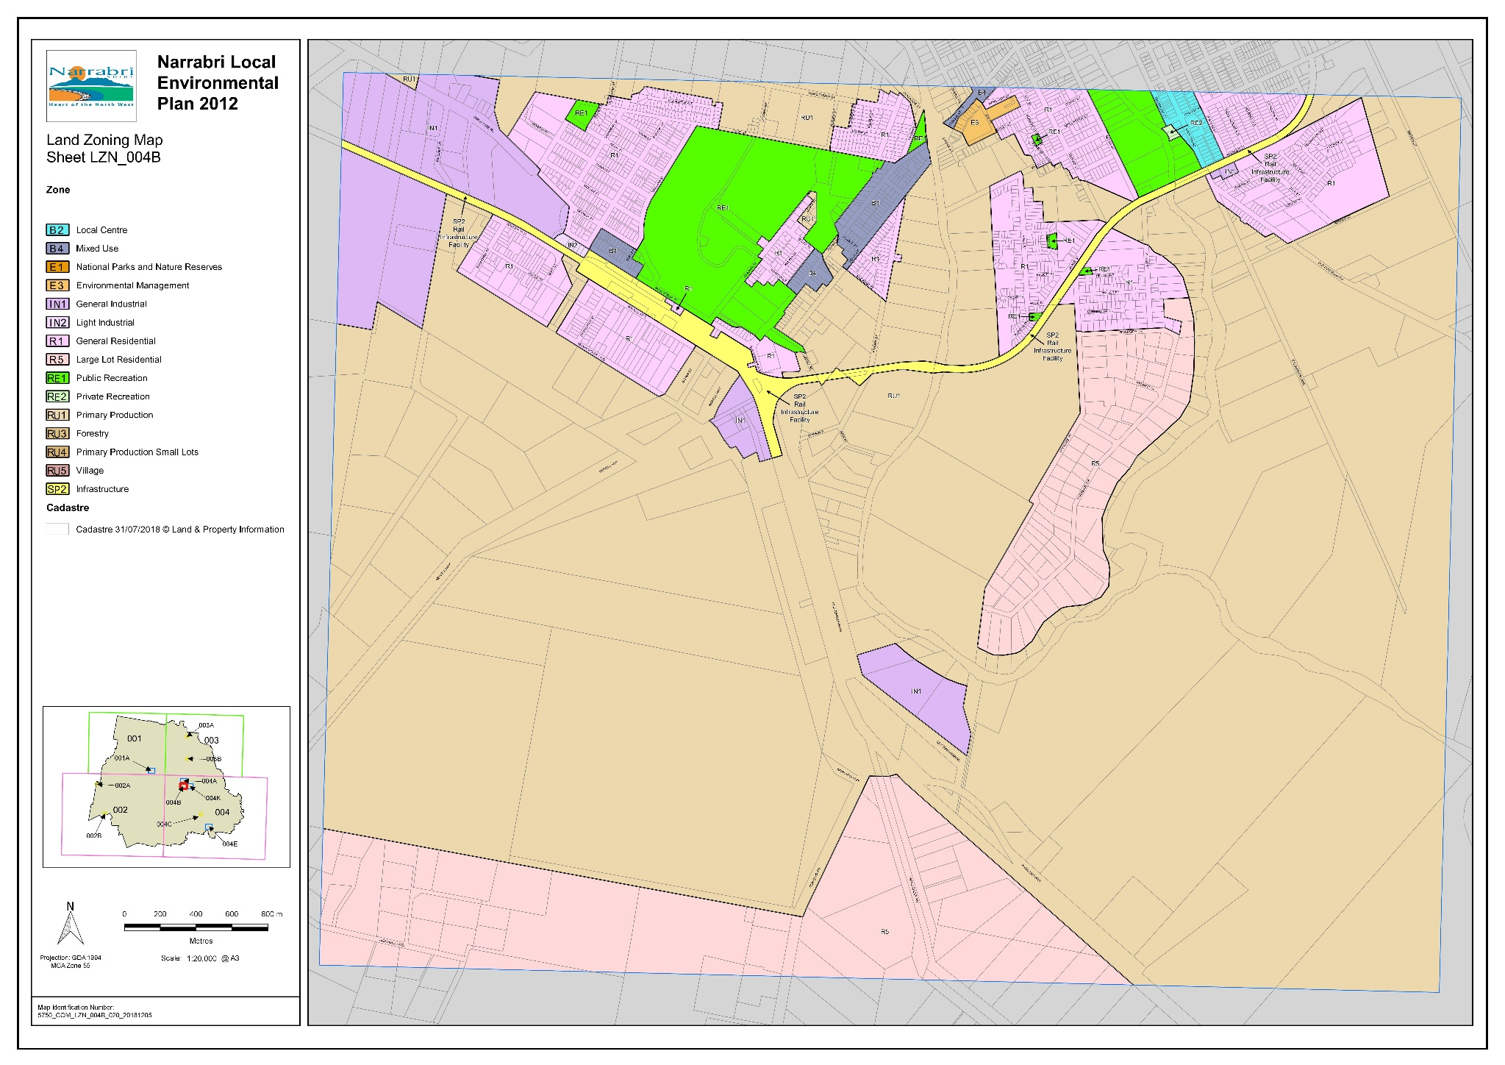

*Figure 2 – Proposed B4 Land Use Zoning.*

At this point it is not intended to delete the B1 Neighbourhood Centre zone from LEP 2012. Removal of the zone from the LEP and the LEP maps will be undertaken at the time of a general housekeeping amendment.

There are no further changes proposed to LEP 2012 or the LEP 2012 maps. In particular there are no changes proposed to Height of Building or Floor Space Ratio provisions or maps as these provisions do not form part of the existing LEP 2012.

The subject land is currently not subject to Minimum Lot Size provisions or maps and there are no proposed changes to the Minimum Lot Size Map as part of this planning proposal.

The planning proposal applies to the following land:

|  |  |  |  |  |
| --- | --- | --- | --- | --- |
| **Property Address** | **Lot / Section** | **DP** | **Existing Zone** | **Proposed Zone** |
| 21 Goobar Street, Narrabri | 1 / 2 | 758756 | B1 Neighbourhood Centre | B4 Mixed Use |
| 19 Goobar Street, Narrabri | 2 / 2 | 758756 | B1 Neighbourhood Centre | B4 Mixed Use |
| 17 Goobar Street, Narrabri | 3A / - | 326074 | B1 Neighbourhood Centre | B4 Mixed Use |
| 15 Goobar Street, Narrabri | 3B / - | 326074 | B1 Neighbourhood Centre | B4 Mixed Use |
| Goobar Street, Narrabri | 4A / - | 326074 | B1 Neighbourhood Centre | B4 Mixed Use |
| 13 Goobar Street | 4B / - | 326074 | B1 Neighbourhood Centre | B4 Mixed Use |
| 11 Goobar Street, Narrabri | 5 / 2 | 758756 | B1 Neighbourhood Centre | B4 Mixed Use |
| 9 Goobar Street, Narrabri | 6 / 2 | 758756 | B1 Neighbourhood Centre | B4 Mixed Use |
| 7 Goobar Street, Narrabri | 7 / 2 | 758756 | B1 Neighbourhood Centre | B4 Mixed Use |
| 5 Goobar Street, Narrabri | 8 / 2 | 758756 | B1 Neighbourhood Centre | B4 Mixed Use |
| 1-3 Goobar Street, Narrabri | 1 / - | 915129 | B1 Neighbourhood Centre | B4 Mixed Use |
| Goobar Street, Narrabri | 10 / 2 | 758756 | B1 Neighbourhood Centre | B4 Mixed Use |
| Goobar Street, Narrabri | 2 / - | 915129 | B1 Neighbourhood Centre | B4 Mixed Use |
| 24 Mooloobar Street, Narrabri | 5 / 3 | 758756 | B1 Neighbourhood Centre | B4 Mixed Use |
| 24A Mooloobar Street, Narrabri | 22 / - | 543782 | B1 Neighbourhood Centre | B4 Mixed Use |
| 26 Mooloobar Street, Narrabri | 21 / - | 543782 | B1 Neighbourhood Centre | B4 Mixed Use |
| 28 Mooloobar Street, Narrabri | 11 / 2 | 758756 | B1 Neighbourhood Centre | B4 Mixed Use |
| 30 Mooloobar Street, Narrabri | 12 / 2 | 758756 | B1 Neighbourhood Centre | B4 Mixed Use |
| 32 Mooloobar Street, Narrabri | 13 / 2 | 758756 | B1 Neighbourhood Centre | B4 Mixed Use |
| 38 Mooloobar Street, Narrabri | 14 / 2 | 758756 | B1 Neighbourhood Centre | B4 Mixed Use |
| 40 Mooloobar Street, Narrabri | 15 / 2 | 758756 | B1 Neighbourhood Centre | B4 Mixed Use |
| 42 Mooloobar Street, Narrabri | 16 / 2 | 758756 | B1 Neighbourhood Centre | B4 Mixed Use |
| 44 Mooloobar Street, Narrabri | 17 / 2 | 758756 | B1 Neighbourhood Centre | B4 Mixed Use |
| 46 Mooloobar Street, Narrabri | 18 / 2 | 758756 | B1 Neighbourhood Centre | B4 Mixed Use |
| 50 Mooloobar Street, Narrabri | 19 / 2 | 758756 | B1 Neighbourhood Centre | B4 Mixed Use |
| Mooloobar Street, Narrabri | 20 / 2 | 758756 | B1 Neighbourhood Centre | B4 Mixed Use |

*Table 1 – Land affected by this planning proposal*

# PART 3: JUSTIFCATION

In accordance with the Department of Planning and Infrastructure’s *Guide to Preparing Planning Proposals,* this section considers the following issues:

* Section A: Need for the planning proposal
* Section B: Relationship to strategic planning framework
* Section C: Environmental, social and economic Impact
* Section D: State and Commonwealth Interests

## SECTION A – NEED FOR THE PLANNING PROPOSAL

1. **Is the planning proposal the result of any strategic study?**

The planning proposal is not a direct result of a strategic study or report. However, the proposal has been informed by a detailed Review of the land use table for the B1 Neighbourhood Centre zone. This Review has also led to the consideration of the vision and goals of the *New England North West Regional Plan 2036* and reconsideration of the *Narrabri Shire Growth Management Strategy 2009*.

It is submitted that the objectives of the planning proposal are not contrary to the objectives or outcomes sought by the *New England North West Regional Plan 2036* and will bring LEP 2012 into alignment with the recommendations of the *Narrabri Shire Growth Management Strategy, 2009* in relation to the land currently zoned B1 Neighbourhood Centre in Narrabri West.

A comprehensive review of the twelve (12) Local Environmental Plans (LEP’s) within the New England North West Regional Plan Area was undertaken as part of this planning proposal. This included the following Local Government Area LEP’s:

* Tamworth
* Moree Plains
* Inverell
* Gunnedah
* Gwydir
* Tenterfield
* Uralla
* Armidale
* Walcha
* Liverpool Plains
* Glen Innes Severn
* Narrabri

Of the twelve (12) LEP’s that were reviewed, Narrabri, Tamworth, Moree and Inverell have a B1 Neighbourhood Centre zone. These LEP’s land use tables have been reviewed in detail and compared to Narrabri’s LEP 2012 in relation to the B1 Neighbourhood Centre zone.

It is also noted that of the twelve (12) LEP’s that were reviewed all of the LEP’s have the B4 Mixed Use zone except for Moree Plains, Inverell, Gwydir and Tenterfield.

Narrabri LEP 2012 contains only one area of B1 Neighbourhood Centre zone which is located in West Narrabri. It is a small pocket of land that is bounded by Burigal Street to the west, Goobar Street to the north, Mooloobar Street to the south and Buri Street to the east with the Narrabri West Post Office also being included in the B1 Neighbourhood Centre zone on the eastern side of Buri Street.

See site location plan below;

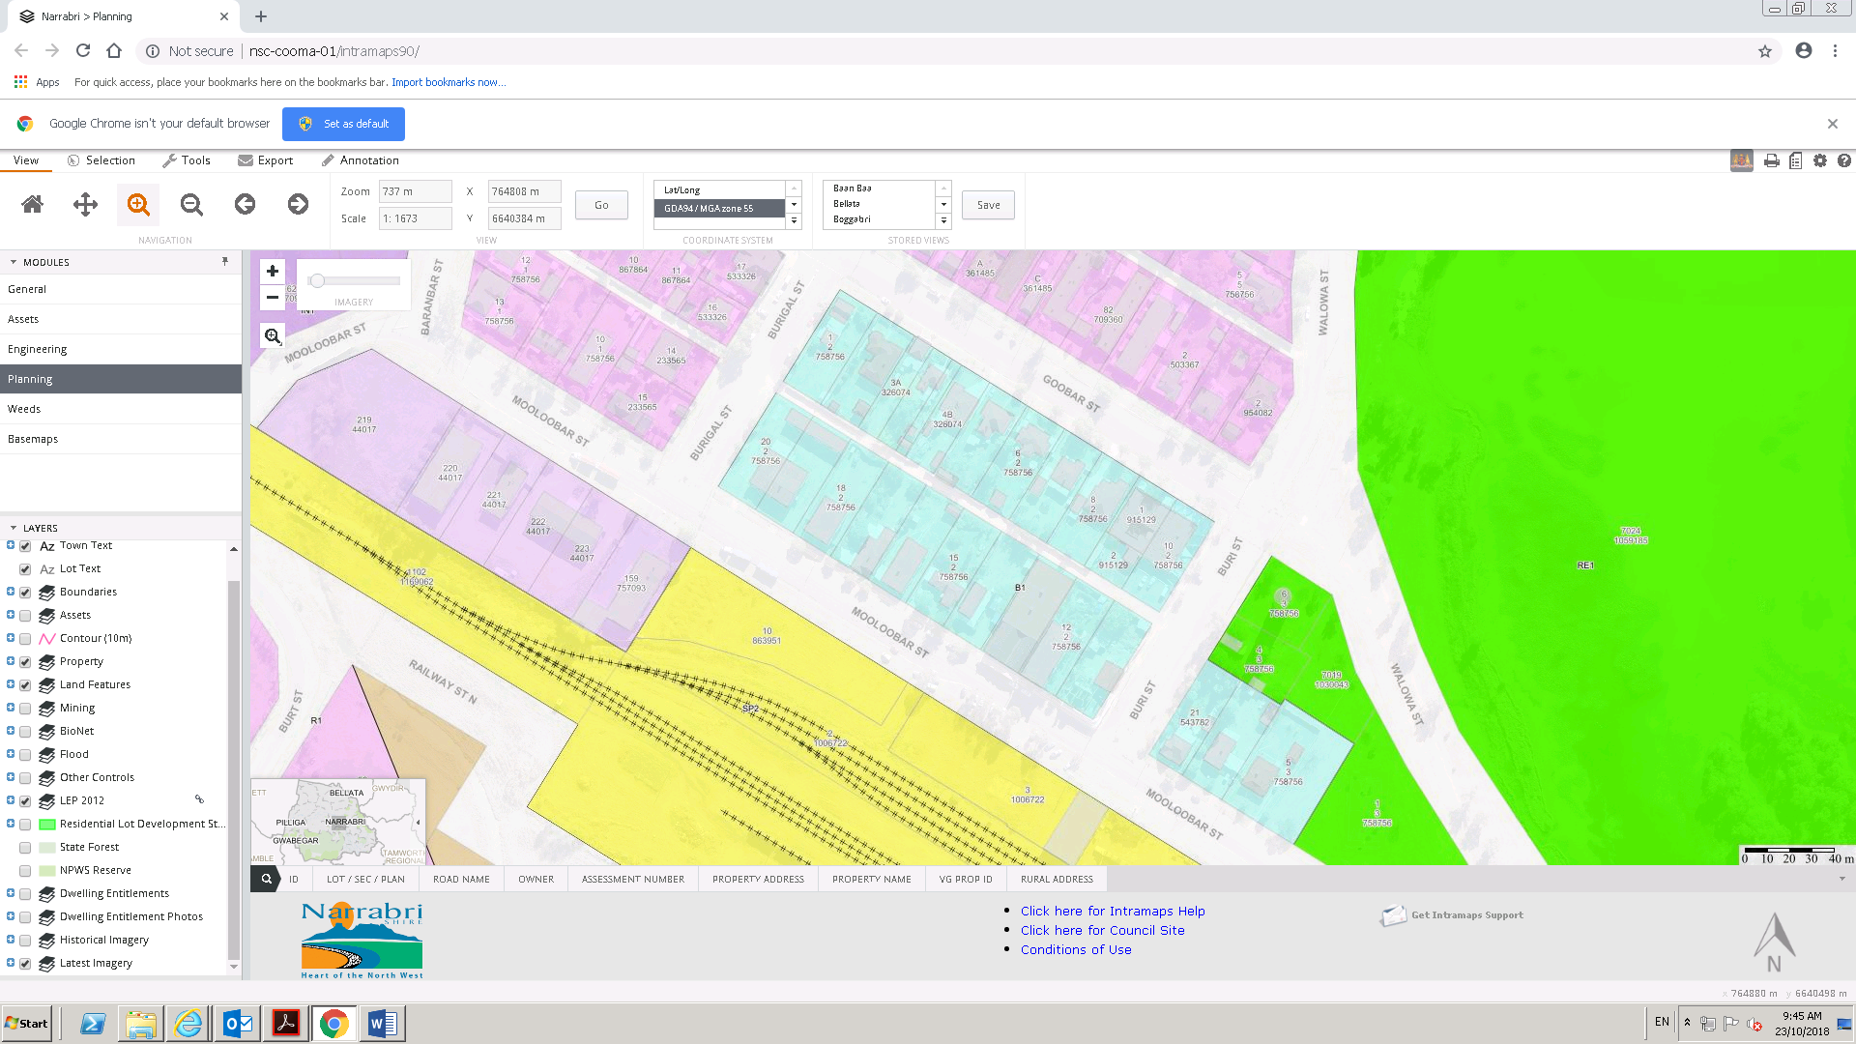

*Figure 3 – Current B1 Zone Location Plan.*

The total B1 Neighbourhood Centre zone is approximately 3ha and contains approximately 26 lots.

A review of the existing land uses within the West Narrabri B1 Neighbourhood Centre zone revealed a mixture of existing commercial land uses along with residential dwellings, a backpackers, a hotel, the West Narrabri Post Office and the Narrabri Christian Fellowship. There are also a number of empty buildings or buildings that require significant repairs.

Narrabri Lake with adjacent recreation and park area bound the B1 Neighbourhood Centre zone on the eastern side with the Narrabri West Walgett Railway Line on the southern side of Mooloobar Street.

The location of the B1 Neighbourhood Centre in close proximity to Narrabri Lake offers the area the opportunity to take advantage of this natural and recreation environment. It is considered that by rezoning the B1 Neighbourhood Centre zone to B4 Mixed Use such uses as recreation facilities and garden centres could be considered offering the opportunity to positively enhance the Narrabri Lake area.

1. **Is the planning proposal the best means of achieving the objectives or intended outcomes or is there a better way?**

It is considered that an amendment to the Narrabri LEP 2012 is the only method to achieve the objectives and outcome sought by this planning proposal.

The objectives and intended outcomes listed in Part 1 of this report have been informed by a review of the prohibited land uses within the Narrabri LEP 2012 B1 Neighbourhood Centre land use zone. This review identified a number of land uses currently prohibited within the zone which may be in the public interest to establish as forms of development permissible with consent.

Consideration was given to opening up the B1 Neighbourhood Centre land uses to enable more land uses to be “permitted with consent” however, upon review of the *Narrabri Shire Growth Management Strategy, 2009* it was identified that the subject land was recommended to be zoned “Mixed Use” under the *Strategy*.

Review of Narrabri Council’s files failed to reveal why the land at West Narrabri was zoned B1 Neighbourhood Centre rather than B4 Mixed Use as recommended.

Consideration was given to the objectives of both the B1 Neighbourhood Centre zone and the B4 Mixed Use zone along with a comparison of the land uses permitted within each zone.

Given the focus of the *New England North West Regional Plan* is to build strong economic centres that enhance the vitality of existing central business precincts, the exiting vacant buildings and blocks within the West Narrabri precinct it is considered that by rezoning this land to B4 Mixed Use the potential for alternative land uses to be considered is a positive.

## SECTION B –RELATIONSHIP TO STRATEGIC PLANNING FRAMEWORK

1. **Is the planning proposal consistent with the objectives and actions contained within the applicable regional or sub-regional strategy?**

The *New England North West Regional Plan 2036*, hereby referred to as the *Regional Plan*, was prepared by the Department of Planning and Environment to give strategic direction to development in the New England North West Region and is a relevant consideration for this planning proposal.

The *Regional Plan* recognises the network of regional cities and centres support diverse industries and that as their industries grow, centres will thrive and require high quality health, education and recreation options. The *Regional Plan* goes on to further recognise the regional cities of Tamworth and Armidale and the strategic centres of Narrabri, Moree, Inverell and Glen Innes will be the focus of employment and services.

The *Regional Plan* identifies four regionally focused goals and Direction’s and Actions as policy measures targeted toward achieving the plans goals.

The goals of the *New England North West Regional Plan 2036* are:

Goal 1 – A strong and dynamic regional economy

Goal 2 – A healthy environment with pristine waterways

Goal 3 – Strong infrastructure and connected transport networks for a connected future

Goal 4 – Attractive and thriving communities

This planning proposal is considered to be compatible with all of the strategic goals in some way. In particular the following Directions are considered relevant to this planning proposal:

*Direction 7: Building Strong Economic Centres –* This planning proposal seeks to rezone the West Narrabri precinct from B1 Neighbourhood Centre to B4 Mixed Use which in turn will provide opportunities for a stronger more diverse precinct to be developed.

Existing land uses will be retained while a range of additional uses could be considered under the Mixed Use zone including Recreation facilities (indoor), Garden centre, Landscape material supplies, Rural supplies and Veterinary hospitals. This provides great diversity and flexibility within the West Narrabri precinct and allows for alternative uses to be considered outside of the B1 Neighbourhood Centre zone.

It is not the intention of this planning proposal to shift the focus of retail and commercial activities outside of the Narrabri CBD rather provide for a mixture of compatible land uses to integrate with the existing low key residential land uses.

*Direction 19: Support healthy, safe, socially engaged and well connected communities –* The *Regional Plan* recognises that the structure and design of communities, including streetscapes, recreation areas and community facilities can influence community health, wellbeing and social cohesion. Housing services and facilities within walking distance of each other, or easily accessible by public transport, make it easier for people to be active while accessing services.

This planning proposal will enhance the opportunity for an appropriate mix of land uses to be considered within the West Narrabri precinct which is generally surrounded by residential development and within walking distance for the West Narrabri community.

This planning proposal does not present any issue in relation to the Actions recommended by the *Regional Plan* as measures to achieve the above Directions and Actions.

1. **Is the planning proposal consistent with the local Council’s Community Strategic Plan or other local strategic plan?**

The *Narrabri Growth Management Strategy* is a local strategic plan which was prepared in 2009 and relates to the entirety of the Narrabri Local Government Area (LGA).

The *Growth Management Strategy* considered the existing commercial areas across the Narrabri LGA in 2009 and found that the existing commercial area was considered appropriate for the short term future. The *Strategy* identified a number of anomalies with commercial type uses being zoned as industrial and residential. In relation to the West Narrabri precinct the *Strategy* states (pg. 164):

*“The neighbourhood business zone in West Narrabri between Goobar, Mooloolaba, Buri and Burgal Streets should be zoned as Mixed Use.”*

A review of Narrabri Council’s files fails to reveal why the land was zoned B1 Neighbourhood Centre rather than B4 Mixed Use under the Narrabri LEP 2012 against the recommendations of the *Strategy.*

1. **Is the planning proposal consistent with applicable State Environmental Planning Policies?**

Yes. This planning proposal is considered to be consistent with relevant State Environmental Planning Policies. The NSW Government publishes State Environmental Planning Policies (SEPPs) for matters of State and regional planning significance. The table below examines the consistency of this planning proposal with the relevant SEPPs;

| **Relevant SEPP/Deemed SEPP** | **Consistency of Planning Proposal** |
| --- | --- |
| State Environmental Planning Policy No. 1 –Development Standards | Not applicable. No variations to development standards sought. |
| State Environmental Planning Policy No. 19 – Bushland in Urban Areas | Not applicable. |
| State Environmental Planning Policy No. 21 – Caravan Parks | Consistent. The planning proposal will allow caravan parks to be permitted with consent under the B4 Mixed Use zone. The planning proposal does not seek any variations to the requirements set out in this SEPP. |
| State Environmental Planning Policy No. 30 – Intensive Agriculture | Not applicable. |
| State Environmental Planning Policy No. 33 – Hazardous and Offensive Development | Not applicable. |
| State Environmental Planning Policy No. 36 – Manufactured Home Estates | Consistent. This SEPP aims to facilitate the establishment of manufactured home estates as a contemporary form of medium density residential development that provide an alternative to traditional housing arrangements. Consideration can be given to a manufactured home estate under the B4 Mixed Use zone given that Caravan Parks are a “permitted with consent” land use in this zone. The planning proposal does not seek any variations to the requirements set out in this SEPP. |
| State Environmental Planning Policy No. 44 – Koala Habitat Protection | Not applicable. |
| State Environmental Planning Policy No. 47 – Moore Park Showground | Not applicable. |
| State Environmental Planning Policy No. 50 – Canal Estate Development | Not applicable. |
| State Environmental Planning Policy No. 24 – Farm Dams and Other Works in Land and Water Management Plan Areas | Not applicable. |
| State Environmental Planning Policy No. 55 – Remediation of Land | Consistent. The objectives of this SEPP are to provide a Statewide planning approach to the remediation of contaminated land and aims to promote the remediation of contaminated land for purpose of reducing the risk of harm to human health or any other aspect of the environment. In preparing this planning proposal, consideration has been given to the whether the land at West Narrabri may be contaminated. A search of Council’s records does not reveal any existing reported contamination within the precinct. The existing land uses are unlikely to have resulted in land contamination. Any future development within the precinct will need to address the requirements of the SEPP. |
| State Environmental Planning Policy No. 62 – Sustainable Aquaculture | Not applicable. |
| State Environmental Planning Policy No. 64 – Advertising and Signage | Consistent. The main objectives of this SEPP is to ensure that signage is compatible with the desired amenity and visual character of an area, ensure that signage provides effective communication in suitable locations and is of a high quality design and finish. The planning proposal does not seek any variations to the requirements set out in this SEPP and any future developments within the precinct will need to address the requirements of this SEPP. |
| State Environmental Planning Policy No. 65 – Design Quality of Residential Apartment Development | Consistent. This SEPP applies to development for the purpose of a residential flat building, shop top housing or mixed use development with a residential accommodation component. The planning proposal does not seek any variations to the requirements set out in this SEPP. |
| State Environmental Planning Policy No. 70 – Affordable Housing (Revised Scheme) | Not applicable. |
| State Environmental Planning Policy (Affordable Rental Housing) 2009 | Not applicable. |
| State Environmental Planning Policy (Building Sustainability Index: BASIX) 2004 | Consistent. Any future developments within the precinct will need to take into consideration the requirements of this SEPP. |
| State Environmental Planning Policy (Coastal Management) 2018 | No applicable. |
| State Environmental Planning Policy (Educational Establishments and Child Care Facilities) 2017 | Consistent. The current B1 Neighbourhood Centre zone provides for consideration to be given to both Educational Establishments and early education and care facilities within the West Narrabri precinct. The B4 Mixed Business zone also allows for these land uses to be permitted with consent. Any future child care centre or the like would need to take into consideration the requirements and provisions of the SEPP. The planning proposal does not seek any variations to the requirements set out in this SEPP. |
| State Environmental Planning Policy (Exempt and Complying Development Codes) 2008 | Consistent. The planning proposal does not seek any variations to the requirements set out in this SEPP. |
| State Environmental Planning Policy (Housing for Seniors or People with a Disability) 2004 | Consistent. As with the B1 Neighbourhood Centre zone, seniors housing and housing suitable for people with a disability can be permitted with consent in the B4 Mixed Use zone. Any future developments of this type would need to take into consideration the requirements and provisions of the SEPP. The planning proposal does not seek any variations to the requirements set out in this SEPP. |
| State Environmental Planning Policy (Infrastructure) 2007 | Future development of land within the West Narrabri precinct may trigger an assessment under this SEPP. In that case the development will need to take into consideration the requirements and provisions of the SEPP. The planning proposal does not seek any variations to the requirements set out in this SEPP. |
| State Environmental Planning Policy (Integration and Repeals) 2016 | Not applicable. |
| State Environmental Planning Policy (Mining, Petroleum Production and Extractive Industries) 2007 | Not applicable. |
| State Environmental Planning Policy (Miscellaneous Consent Provisions) 2007 | Consistent. The planning proposal does not seek any variations to the requirements set out in this SEPP in relation to temporary structures, subdivision, change of use, demolition and fire alarm communication links. |
| State Environmental Planning Policy (Rural Lands) 2008 | Not applicable. |
| State Environmental Planning Policy (State and Regional Development) 2011 | Consistent. The planning proposal does not seek any variations to requirements set out in this SEPP. |
| State Environmental Planning Policy (State Significant Precincts) 2005 | Not applicable. |
| State Environmental Planning Policy (Urban Renewal) 2010 | Not applicable. |
| State Environmental Planning Policy (Vegetation in No-Rural Areas) 2017 | The planning proposal applies to land in West Narrabri that is a well-established residential, commercial and retail area. The planning proposal will not impact any existing significant vegetation. |

*Table 2 – Consistency with SEPPs.*

1. **Is the planning proposal consistent with applicable Ministerial Directions (s.117 Directions)?**

The Minister for Planning issues Local Planning Directions that Council must follow when preparing a planning proposal. The directions cover the following broad categories:

* Employment and resources
* Environment and heritage
* Housing, infrastructure and urban development
* Hazard and risk

Each S. 9.1 Ministerial Direction is listed in the table below with an annotation stating whether it is relevant to the planning proposal and comments relating to its consistency with the corresponding objective;

| **S. 9.1 Direction Title** | **Consistency of Planning Proposal** |
| --- | --- |
| 1.1 Business and Industrial Zones | Inconsistent but justified. It is recognised that the planning proposal potentially alters the opportunity for some employment uses within the West Narrabri area. However, the planning proposal does not seek to alter the area, location or amount of business land that exists at West Narrabri. The rezoning from B1 Neighbourhood Centre to B4 Mixed Use allows the opportunity for a wider variety of suitable land uses for the area to be considered. The existing LEP 2012 does not contain provisions relating to Floor Space Ratios or Height of Buildings and the planning proposal does not seek to change this. Nor does the planning proposal include the introduction of a Minimum Lot Size requirement to the subject land. It is unknown why the land subject of this planning proposal is zoned B1 Neighbourhood Centre under LEP 2012. The planning proposal brings LEP 2012 into alignment with the *Narrabri Shire Growth Management Strategy* for the West Narrabri precinct which recommends that this land be zoned Mixed Use. In particular the *Growth Management Strategy* recognises that there are a *“few anomalies”* including the following (page 164):  *“The neighbourhood business zone in West Narrabri between Goobar, Moolooaba, Buri and Burigal Streets should be zoned as Mixed Use”.*  Whilst the planning proposal may be considered inconsistent with this Direction due to potentially alternative land uses being permitted with consent this inconsistency is considered justified. |
| 1.2 Rural Zones | Not applicable. The planning proposal does not propose to rezone rural land and will not affect the provision of this Direction. |
| 1.3 Mining, Petroleum Production and Extractive Industries | Not applicable.  The land to which this planning proposal applies to is within an established residential, commercial and retail precinct. |
| 1.4 Oyster Aquaculture | Not applicable. |
| 1.5 Rural Lands | Not applicable. The planning proposal does not propose to rezone rural land and will not affect the provision of this Direction. |
| 2.1 Environment Protection Zones | Not applicable. The planning proposal does not propose to rezone environmental land and will not affect the provision of this Direction. |
| 2.2 Coastal Protection | Not applicable. |
| 2.3 Heritage Conservation | Consistent. Schedule 5 – Environmental Heritage of LEP 2012 identifies two heritage items that may be impacted by the planning proposal.  Heritage Item I035 – Railway Station Precinct is located within the land subject to this planning proposal, with Heritage Item I036 – War Memorial, Narrabri West adjoining the land subject to this planning proposal.  The planning proposal does not seek to modify provision 5.10 – Heritage Conservation of LEP 2012 which would continue to apply to any future development within the West Narrabri precinct. |
| 2.4 Recreation Vehicle Areas | Not applicable. |
| 2.5 Application of E2 and E3 Zones and Environmental Overlays in Far North Coast LEPs | Not applicable. |
| 3.1 Residential Zones | Consistent. The objectives of the B4 Mixed Use zone along with the permitted with consent land uses allows for the consideration of a wider variety of building types under the B4 Mixed Use zone compared to the B1 Neighbourhood Centre zone. The West Narrabri precinct already has access to existing services and infrastructure and therefore will not be impacted by this planning proposal. |
| 3.2 Caravan Parks and Manufactured Home Estates | Consistent. The B4 Mixed Use zone put forward under this planning proposal for the West Narrabri land allows for the consideration of caravan parks and manufactured home estates. The existing B1 Neighbourhood Centre zone prohibits this land use. It is considered that a caravan park may be a suitable use within the West Narrabri precinct but is unlikely to be proposed due to the multiple land ownership. |
| 3.3 Home Occupations | Consistent. The planning proposal will retain the provisions of the principle LEP which provides for this use without consent in most circumstances. |
| 3.4 Integrating Land Use and transport | Consistent. The planning proposal does not propose to alter area or location of the B1 Neighbourhood Centre zone, rather change the zone to B4 Mixed Use. This allows for wider variety of land uses to be considered in the West Narrabri precinct that could offer additional services, jobs and housing in the area. This in turn may reduce travel demand, especially by car for local area. |
| 3.5 Development Near Licensed Aerodromes | Not applicable. The land subject of this planning proposal is not located near a licenced aerodrome. |
| 3.6 Shooting Ranges | Not applicable. The land subject to this planning proposal is not located near an existing shooting range. |
| 4.1 Acid Sulfate Soils | Not applicable. |
| 4.2 Mine Subsidence and Unstable Land | Not applicable. |
| 4.3 Flood Prone Land | Consistent. The land subject to this planning proposal is identified as flood prone land. The planning proposal does not directly affect provisions relating to flood prone land. Flood policy would continue to be enforces on flood-prone land and any future Development Applications will be required to address these requirements. |
| 4.4 Planning for Bushfire Protection | The planning proposal would not affect existing bushfire planning provisions. These provisions would continue to be enforced for developments on bushfire prone land. |
| 5.1 Implementation of Regional Strategies (Revoked 17 October 2017) | Not applicable. |
| 5.2 Sydney Drinking Water Catchments | Not applicable. |
| 5.3 Farmland of State and Regional Significance on the NSW Far North Coast | Not applicable. |
| 5.4 Commercial and Retail Development along the Pacific Highway, North Coast | Not applicable. |
| 5.5 Development in the vicinity of Ellalong, Paxton and Millfield (Cessnock LGA) (Revoked 18 June 2010) | Not applicable. |
| 5.6 Sydney to Canberra Corridor (Revoked 10 July 2008) | Not applicable. |
| 5.7 Central Coast (Revoked 10 July 2008) | Not applicable. |
| 5.8 Second Sydney Airport: Badgerys Creek | Not applicable. |
| 5.9 North West Rail Link Corridor Strategy | Not applicable. |
| 5.10 Implementation of Regional Plans | Consistent. The planning proposal is considered consistent with this Direction as outlined in Section B, Part 3 of the document. The planning proposal is considered to enhance the focus of the retail and commercial activities on the Narrabri CBD by preventing neighbourhood shops and supermarkets being allowed in the West Narrabri precinct. The intention of the planning proposal is to provide a wider range of compatible mixed land uses to be considered in the West Narrabri precinct. |
| 6.1 Approval and Referral Requirements | Consistent. The planning proposal does not contain any additional provisions requiring concurrence, consultation or referral of development applications to a Minister or public authority. |
| 6.2 Reserving Land for Public Purposes | Not applicable. The planning proposal does not relate to the reserving of land for public purposes nor the removal of reservations on public land. |
| 6.3 Site Specific Provisions | Not applicable. The planning proposal does not propose any site specific provisions for the land at West Narrabri. |
| 7.1 Implementation of A Plan for Growing Sydney | Not applicable. |
| 7.2 Implementation of Greater Macarthur Land Release Investigation | Not applicable. |
| 7.3 Parramatta Road Corridor Urban Transformation Strategy | Not applicable. |
| 7.4 Implementation of North West Priority Growth Area Land Use and Infrastructure Implementation Plan | Not applicable. |
| 7.5 Implementation of Greater Parramatta Priority Growth Area Interim Land Use and Infrastructure Implementation Plan | Not applicable. |
| 7.6 Implementation of Wilton Priority Growth Area Interim Land Use and Infrastructure Plan | Not applicable. |
| 7.7 Implementation of Glenfield to Macarthur Urban Renewal Corridor | Not applicable. |

*Table 3 – Consistency with Ministerial Directions.*

The planning proposal has considered all Ministerial Directions and is consistent with the Local Planning Directions as outlined above. Any inconsistencies have been justified.

**SECTION C – ENVIRONMENTAL SOCIAL AND ECONOMIC IMPACT**

1. **Is there any likelihood that critical habitat or threatened species, populations or ecological communities, or their habitats, will be adversely affected as a result of the proposal?**

This planning proposal will not have an adverse impact on critical habitat or threatened species, populations or ecological communities, or their habitats as the land is already largely developed and under a Business zone. Any Development Applications within the West Narrabri precinct will be subject to normal merit assessment with impacts on the environment needing to be considered and addressed.

1. **Are there any other environmental effects as a result of the planning proposal and how are they proposed to be managed?**

As with a large percentage of Narrabri, the West Narrabri precinct is identified within the Flood Planning Area and therefore is subject to Clause 6.2 Flood Planning of LEP 2012. As outlined in this planning proposal the West Narrabri precinct is already largely developed with a mixture of residential, commercial and retail type business. Any Development Applications within the precinct will be required to address the provisions of the LEP 2012 and any other environmental matters relevant to the proposal.

It is not considered that this planning proposal would give rise to any significant environmental effects.

1. **How has the planning proposal adequately addressed any social and economic effects?**

It is considered that the planning proposal would have minor positive social and economic effects. The proposal will enable the existing land uses within the precinct to continue but also offer alternative land uses to be considered that are currently not availed under the B1 Neighbourhood Centre.

The planning proposal delivers increased opportunity for alternative uses such as garden centres, recreation facilities (indoor), veterinary hospital to be “permitted with consent” which are currently “prohibited” under the B1 Neighbourhood Centre zone. It is also considered that by rezoning the West Narrabri precinct to B4 Mixed Use, the Central Business District of Narrabri is reinforced as being the core location for such land uses as supermarkets.

**SECTION D – COMMONWEALTH AND STATE INTERESTS**

1. **Is there adequate public infrastructure for the planning proposal?**

Not applicable. It is considered that there are no additional infrastructure implications from this planning proposal.

1. **What are the views of State and Commonwealth public authorities in accordance with the Gateway determination?**

Relevant State and Commonwealth Government Agencies will be consulted in accordance with the requirements of any Gateway Determination.

**PART 4: MAPPING**

The following mapping is included in the planning proposal:

Attachment 1 Current Zoning

Attachment 2 Proposed Zoning

**PART 5: COMMUNITY CONSULTATION**

In accordance with the *NSW Department of Planning Guidelines to preparing LEP’s*, upon Gateway Determination adjoining landholders and any affected community organisations will be formally notified of the proposal and invited to provide comment.

In accordance with prevailing Departmental Guidelines and the provisions of the Environmental Protection Authority Act, the Planning Proposal will also be notified publicly for the prescribed period in local newspapers and Council’s website at <http://www.narrabri.nsw.gov.au/>

Public exhibition will be carried out in accordance with the requirements of the EPA Act, EPA Regulations and the Gateway Determination.

**PART 6: PROJECT TIMELINE**

It is expected that the relevant steps in the planning proposal process will be completed as set-out in the table below:

|  |  |
| --- | --- |
| **Milestone** | **Timeframe** |
| Council endorse the Planning Proposal | December 2018 |
| Gateway Determination issued by the Department of Planning and Environment | February 2018 |
| Completion of technical assessment | March 2019 |
| Public exhibition of the planning proposal and any required consultation with any public authorities | April 2019 |
| Consideration of any submissions received made during public notification/consultation | May 2019 |
| Refer proposal to Parliamentary Counsel and obtain Opinion | June 2019 |
| Determination to make the LEP and notification of the LEP on legislation website | July 2019 |

**Note:** this project timeline has been drafted on the assumption that Council will be permitted to utilise its delegated plan making powers by the Department of Planning and Environment. Timeframes for achieving milestones may be subject to change pending issues arising during the planning proposal process.